Visual toolkit | Written toolkit
- What size is the image?  - Where is the image located on the page?  - What proportion is it compared to other elements on the page?  - How does the image interact with the written text?  - What style of image is it?  - What colours/tone are used?  - What camera shot and angle is used?  - What is scene in the frame? What is not seen in the frame?  - Is the image symbolic?  - Are people used in the image? What is the relationship between them?  - Are there comments being made on gender, socio-economic ideals, education level, age, profession etc?  - Are stereotypes being used?  - Are the images symbolic?  - Do the images represent a particular time and place?  - If there is more than one image on the page, how do they connect together?  - Is there movement with the images?  - What connotations come with the image?  - If in frames, how do the images develop and/or move from one to the other?  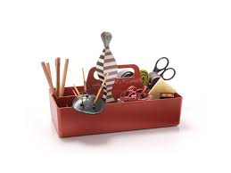 | - What is the style of the font?  - What is the font size?  - Where is the heading located?  - Are there sub-headings?  - Are quotations used?  - Is punctuation used?  - What information is given and what is left out?  - How does the written text link to the images on the page?  - How do the images and text relate to each other structurally?  - What is the tone?  - What is the mood that is created?  - Look carefully at diction.  - Is jargon being used?  - Are facts and statistics used?  - Is figurative/emotional language used?  - Placement of the written text on the page?  - Composition of visual and written text on the page?  - How is the information given? Through captions, paragraphs, bullet points, text boxes, links etc  - How does the information develop from the top to the bottom of the page?  - Are words italicized, bold, in a different font?  - What kind of language is being used? Eg: neologism, archaic, abbreviations etc

